Proposed Design Concept of a Small-Scale Wind Turbine for Power Generation in Coastal Tanzania

Daniel Yednock, Jeffrey Will, Cyrus Darvish, and Nicole Polakovic
Team 8.5, ME 340, Mechanical Engineering Department, Pennsylvania State University

Summary

As Penn State engineering students, we are required to complete a course during our junior year about design methodology. This course is designed to accustom each student to the design process and work professionally in a team. Over the course of this semester, our team is tasked with developing a small-scale wind turbine that generates 0.5-1 W for a remote location that is not connected to the electrical grid. The location our team decided would benefit the most from the turbine is Tanzania, Africa. Over the course of this document, we will discuss in detail a possible application for our small-scale wind turbine and our design process for our final wind turbine design.
In the proposed design section, we will provide a detailed explanation of how we choose our blade, base, and transmission design. Our group decided on having a 3-blade wind turbine with just a generic base design. For our transmission design, we decided to take a risk and went with a belt pulley system. This will be the unique feature of our wind turbine, which was one of the needs given to us by the professor for our wind turbine. The last part of this section will explain our calculation for the efficiency of our wind turbine, which we calculated to be 16 percent efficient.
After the proposed design section, you will find the CAD drawing for our final wind turbine design. This drawing will be an assembly of all of our parts and will show how they fit together and the overall function of our design. In addition, you can find the detailed drawings of all the individual parts that are in the assembly in Appendix B. Finally, the last major section will discuss our management plan for the entire project. Here you will find our Gantt chart that we created in order to stay organized and meet all the deadlines for the proposal report and the presentation.

Statement of Problem

Two of the main challenges faced in developing countries today are a lack of clean, drinkable water and access to electricity. The absence of a widespread electrical grid does not provide a reliable source to power purification systems in these regions. Today, it is estimated that 785 million people do not have access to safe drinking water, which is equivalent to one out of every nine people across the world [2]. Our team has been tasked by the Mechanical Engineering Department at Penn State with designing a small-scale wind turbine that benefits people in need of a power source. Many of the clean water shortages are in Africa, and Tanzania is among the most greatly affected. Only 57% of the country’s population has access to safe water, which is drastically below the global average [3]. A small-scale wind turbine could be used to help solve this crisis in Tanzania.
The process of purifying water can be completed by using the electricity generated from the small-scale wind turbine. One way of purification is by using an ultraviolet light to kill bacteria and disinfect the water. This high energy light is most commonly known as being responsible for causing sunburn, but it can also be utilized to sterilize drinking water [8]. The proposed wind turbine is expected to generate 0.5 - 1 W, which is sufficient to power a small LED UV light. As the contaminated water flows through a dark chamber in the purifier, it is exposed to the UV light source. At a slow enough flow rate, the light destroys any organic material in the water and also prevents reproduction of bacteria cells by destroying genetic material. When set up correctly, the UV light can kill 99.9% of harmful bacteria found in the water. As shown in Figure 1, the most common wavelength of light used in this application is 264 nm. Ultraviolet light is not in the visible light spectrum and therefore will not be able to be seen by the user. Additional benefits of this method of water purification are the lack of adding unwanted tastes, color, odor, or chemical byproducts compared to alternative methods. This process is safe for both the user and also the environment.

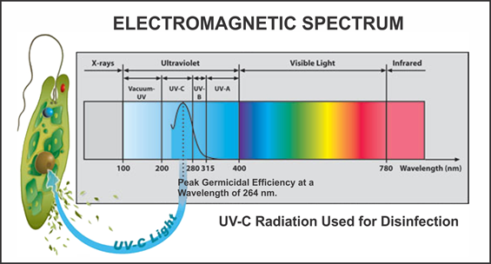
Figure 1. The electromagnetic spectrum shows ultraviolet light with wavelengths between 100 and 400 nm, but 264 nm is the most effective wavelength for water purification [8].

Not only will the turbine provide a solution for this critical problem, but the turbine will also be adequately supported for operation in the coastal Tanzania region. The location that our team decided to focus on specifically for this project is the coastal city of Mtwara, as shown in Figure 2. According to the Global Climate Station Summaries provided by NOAA, the recorded average wind speed is 11.5 miles per hour [5]. With these estimated wind speeds, the turbine would be able to generate around 0.5 - 1 W, which is our expected range. This amount of power is adequate to run a small ultraviolet LED light required to purify the water. According to our team’s calculations, users would be able to purify 1 gallon of water every ten minutes, or 6 gallons an hour. Based on the daily average amount of water needed per day, which is slightly under one gallon, the purifier would be able to provide a family of up to 6 the necessary drinking water each day [12]. In as little as an hour, an entire family would have the recommended amount of clean drinking water needed for the day. This system will save families valuable time needed to perform other daily operations like caring for children and going to school [ ]. Because oftentimes clean water is not located nearby, people have to travel to water sources and carry it back in storage containers. Not only will users save time, their water could also be cleaner than the water gathered from other previously-used sources. People run the risk of contaminating their clean water if their containers are not properly cleaned from previous uses.

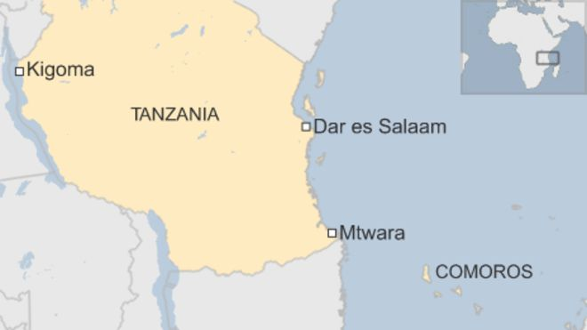
Figure 2. An overview of Tanzania with the city of Mtwara located in the lower right hand corner of the country [ ]. Our team has proposed that the small-scale wind turbine will be located in this region.

Proposed Design for Wind Turbine

This document proposes a design concept for a small-scale wind turbine to provide power in an off-grid application. The value that a wind turbine of this size could provide to an off-grid location would be invaluable to its inhabitants. Examples of these applications include but are not limited to, powering lights, running small appliances, charging phones and purifying water. When selecting and developing the concept for our wind turbine, some assumptions were made. The first assumption is that the wind turbine would receive a constant wind supply. The wind provided from a box fan would satisfy this and enable us to compare our designs when testing different concepts. Without this constant, our team would not know if one turbine design is better than another because the differences in energy output may be due to variation in wind, not differences in design.
While some assumptions simplified comparison between designs, others created more complicated limitations and constraints in developing concepts. The first of these limitations was the budget as each team was given $50 to build their prototype wind turbines. This constraint made the creation of design concepts challenging because it limited the amount of high quality components and exotic materials that could be used. A strong focus was placed on using the budget to purchase materials in the most efficient manner possible. The other major limitation that was placed on our team was the provided motor. The size and speed of the motor limits the amount of power that can be generated. Since the provided motor is only capable of generating 0.5 - 1 watt of power, our team would not be able to generate a higher amount of power.
In the following subsections, our team discusses the steps taken to select a final design concept for our wind turbine. In the first subsection, we examine the prototype needs and accompanying metrics and specifications. The next subsection explains the function structure and system decomposition process. Presented in the third subsection are the methods used to generate concepts for our wind turbine. Finally, the last two subsections present the screening and selection process that we used to determine our final concept and the efficiency of this concept.

Prototype Needs and Accompanying Metrics and Specifications
For this project, our professor specified four prototype needs: electrical power generation, durability, aesthetically pleasing, and a unique feature included. First and foremost, the wind turbine must generate electricity when supplied with wind from a box fan. The turbine must also be durable and withstand a high wind test. In addition, the wind turbine must be aesthetically pleasing, have a finished look, and contain no craft supplies. The turbine must contain a unique feature that makes it better in regards to one of the other needs or makes it stand out. Our team identified one more prototype need; the wind turbine must be no larger than the box fan. This is because if it is larger than the box fan it won’t be as efficient. To see if our team meets the customer needs, we developed eight metrics as shown in Table 1. These metrics include: amount of power generated, withstands leaf blower test, one 3D printed component, one machined component, multiple blades, fits the box fan, cost, and high aesthetic rating. Our team chose these metrics because they could be represented numerically by measurable quantities and allowed us to create target values for the concepts.
When creating the metrics needed to test our concept designs, our team also developed target specifications to quantify the different aspects. First, the turbine is expected to generate between 0.5 - 1 W of power. This range allows the turbine to be useful for many different applications. Next, the turbine should withstand 13 seconds in high wind at a distance of 13 feet. The wind turbine must also include one 3D printed component and one that was traditionally manufactured to satisfy the aesthetically pleasing need. In addition, the turbine should include more than one blade and should be between 1 and 3 feet in size to help generate power. Based on our given budget, the total cost of the project should not exceed $50. Lastly, the turbine should receive a rating between 6 - 10 when judged for its aesthetics. In the next subsection, the function structure and system decomposition of our wind turbine will be discussed.

Table 1. Customer needs and accompanying metrics and specifications for a wind turbine.
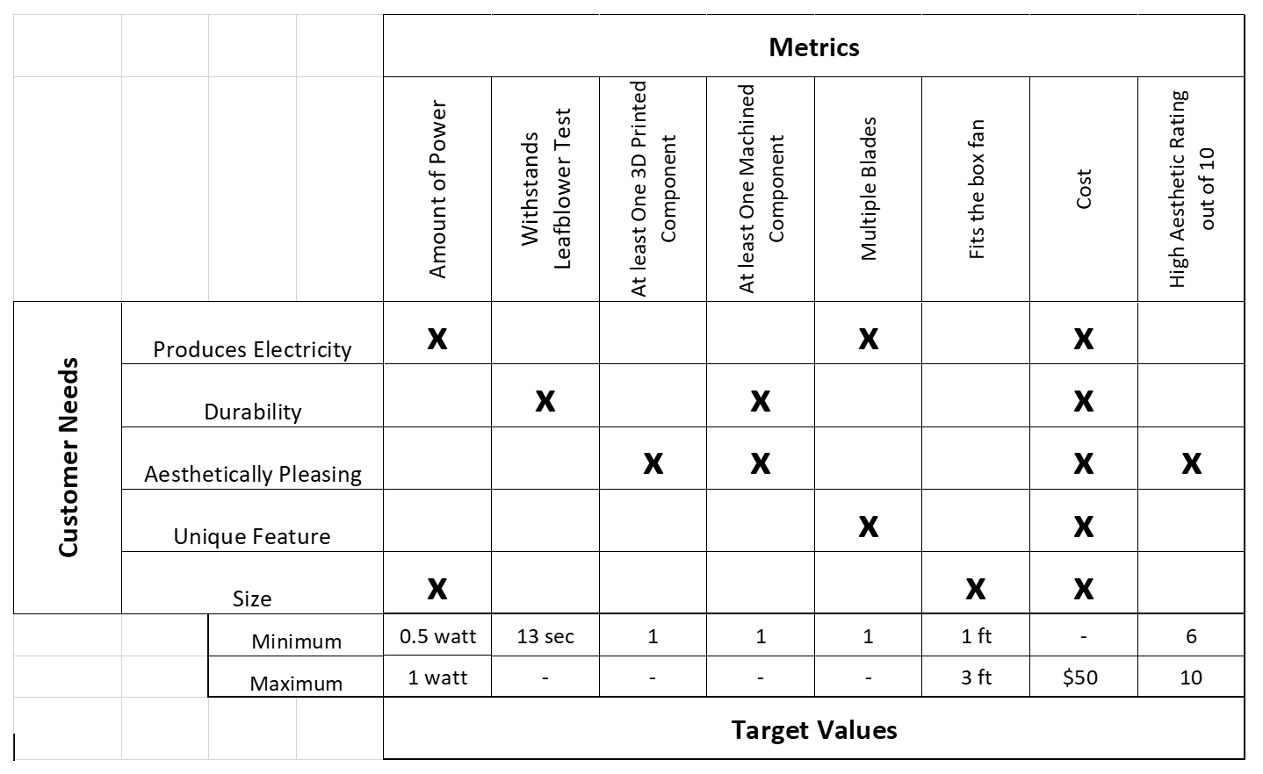

Function Structure and System Decomposition
This subsection presents a discussion of the function structure and system decomposition that our team performed on a generalized wind turbine design. A functional decomposition lays out the various subsystems necessary for a design and how they are all related. By looking at the inputs and outputs of a turbine, we learn what is needed to design this system and what resources we have to work with. This will help us to focus our concept generation to the most important features and allow our group to have a basic layout of our final design from the beginning.
Figure 3 shows the system decomposition of a small-scale wind turbine. Our group decided that the 5 subsystems that must be included in our turbine design are to collect kinetic energy, convert to mechanical energy, convert to electricity, power UV light, and filter water.
The inputs and outputs in Figure 3 are shown in red and include energy, material, and signal flows. These originate from the surrounding environment or are resulting products of the wind turbine. The system signals are shown in green and must be initiated by the user. Any system signals that have a dotted line are used to shut the system down when finished.
Starting from the top-left, wind enters the turbine as the brake is turned off. Our turbine will collect the kinetic energy of the wind through the blades and then the wind will exit through the backside of the turbine. As the blades spin, the kinetic energy will be converted into mechanical energy by rotating the shaft. This shaft rotation will spin the generator and electricity will be produced. Our design will use this electricity to power a UV light when the light switch is turned on. The UV light fixture will be located inside of a water purification filter and the contaminated water will be exposed to the light as it passes through. The end result will be clean, drinkable water. Finally, once a sufficient amount of water is filtered, the user will turn off the UV light and reapply the turbine brake to shut the system process down.

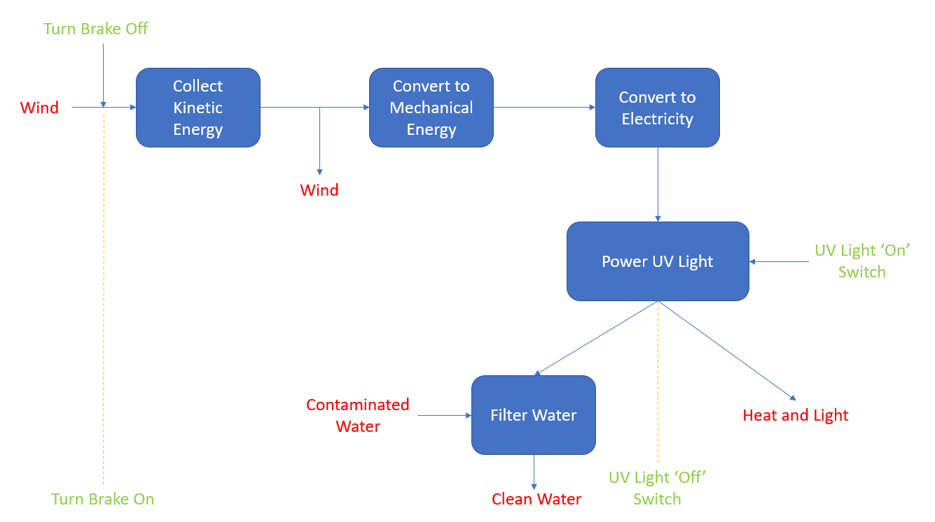
Figure 3. The function structure and system decomposition of the main components of a small-scale wind turbine. System signals are shown in green and inputs/outputs are shown in red.

Concept Generation
At this point in the design process, our team was ready to start concept generation. Using the information identified in the previous sections would allow us to establish the four main design considerations of the wind turbine. These considerations are blade design, stand design, turbine protection, and power transmission. The next step in generating concepts was to brainstorm together as a team.
We begin brainstorming with the 6-3-5 method. This method's goal is to have focused brainstorming on each design consideration. Each member of the team started with one of the main four designs and were given five minutes to generate three ideas for that category. After the five minutes were complete, we passed our ideas to the next person where they had five more minutes to create three new ideas. This process was repeated until it reached back to the first person. The first person would then write three more ideas to complete this concept generation process. Within each round, we would add a new criteria that the ideas would have to follow, for example, you had no money or needed to generate the worst possible idea. You will find a list of our generated ideas for each subsystem from this method in Table 2.
Two other methods of brainstorming that our team tried were the ‘Do Nothing’ and ‘Plus, Minus, Interesting’ methods. The’ Do Nothing’ method is used to identify why you are trying to solve a problem and if the problem actually needs solved. Without a purpose for the project, your team is limiting itself and won’t be able generate the best possible ideas for the wind turbine. What we learned from this was that if we did nothing we would fail the project, learn no new skills, and not use our strengths to benefit our other team members in learning. The PMI (Plus, Minus, Interesting) is a method of making lists of ideas and rating them. This process gave us the ideas that having many blades, a ridge shaft, and being lightweight would be positive ideas.

Table 2. Generated concepts for each sub-function in our small scale wind turbine.
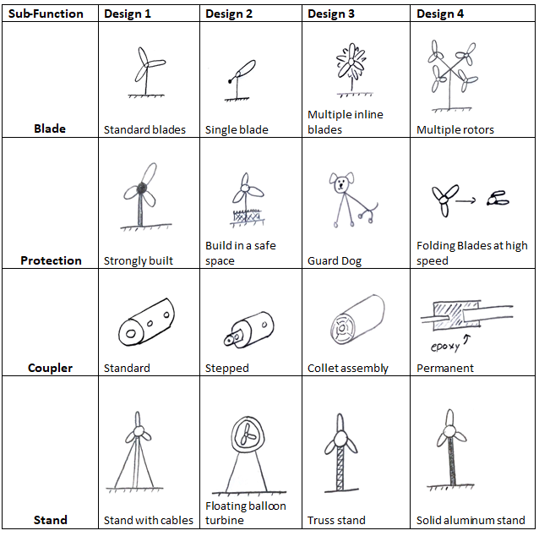

Concept Screening
To narrow down our choices of design concepts, this subsection presents a screening of the concepts generated in the previous subsection. A combination of scoring and appeal was necessary to pick the best design. The most efficient way to determine which concepts to select is the concept screening matrix.
The concept screening matrix involves a summation of the pros and cons(plus represents pro, minus represents con, and 0 represents neither a pro nor con) of each design concept and determines a score for the concept. The scores are then ranked from best to worst and from that we can determine which design is the best for our turbine. Our team decided upon having a scoring matrix for the four different aspects of the turbine: support, protection, coupler, and blade design concepts. As included in Table 3 and Appendix D, each matrix includes unique design metrics that fit the specific section of the turbine. Support includes ease of manufacture, durability, aerodynamics, aesthetics, and uniqueness. Protection includes durability, reliability, strength, weather resistance, and uniqueness. The coupler’s criteria includes concentricity, ease of removability, ease of manufacture, balance, and uniqueness. Finally, the blade design is determined by concentricity, balance, durability, the number of blades, and uniqueness (in this case, a duct). Once the screening process was complete, we decided to continue with either the first or second ranked item, and leave behind the third and fourth ranked concepts.

Table 3. Concept screening matrix for the blade design.
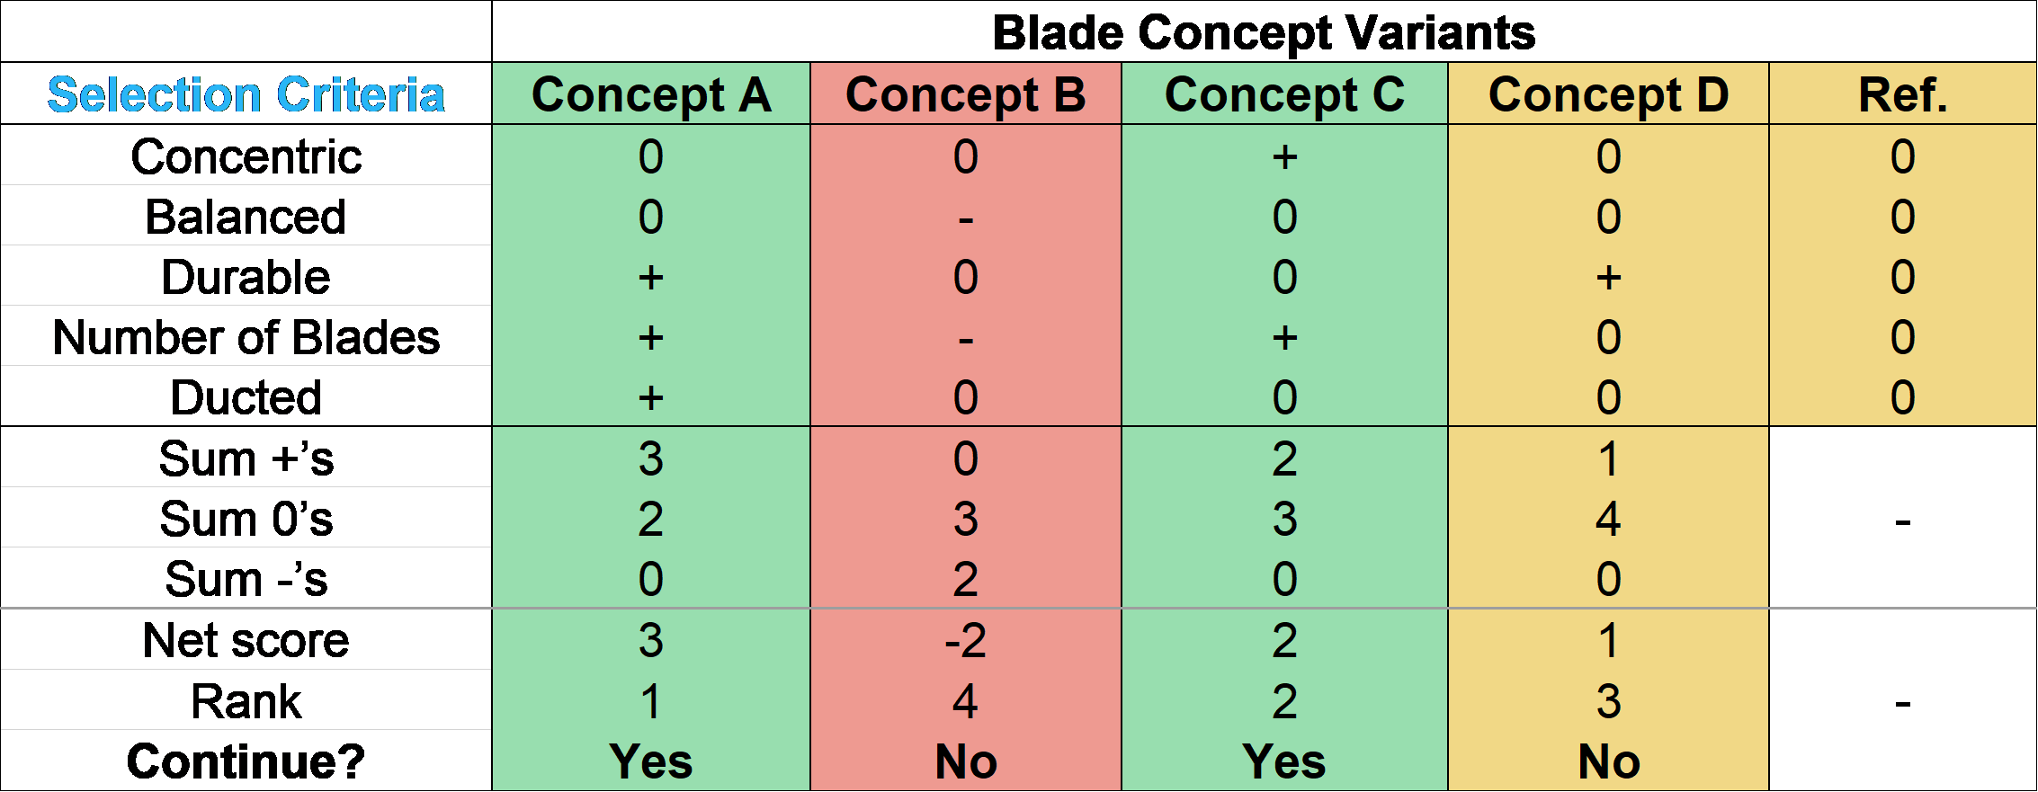
Note - Concepts in order from left to right: Four rotors coupled together, single blade, multiple inline rotors, thin blades.

Concept Selection
After screening several designs, we continued with the top two designs for each subsection. For support, we continued with a stand with cables connected to the base and a three dimensional truss stand. For protection, we proceeded with a design that can sustain high speeds and a foldable blade design. For the coupler design, we advanced with a stepped coupler and a callet assembly. Lastly, for the blade design we went with a design that includes four rotors in a plus shape that are on the same vertical plane and a design that includes multiple rotors in line with each other. Once we knew which designs to progress with for each subsystem, we were able to combine these concepts to generate ideas for complete turbine systems. We ended up with three different designs. The first of three designs includes four separate rotors in a plus shape. We determined the plus shape by recording the rpms of the box fan in 9 different sections of the fan itself and put our rotors where the wind was the highest. The second of these designs consists of a single, ducted rotor. The third and final design includes two, concentric rotors that are in line with one another. After our team generated three turbine designs to continue with, we ran the concepts through a concept scoring matrix.
The concept scoring matrix includes the three designs we continued with and a set of selection criteria. The selection criteria used for the concepts originates from the needs presented to us by the professor that are explained in the ‘Prototype Needs and Accompanying Metrics and Specifications’ section. The criteria includes production of electricity, durability, aesthetically pleasing, unique feature, and size. The weights for each criteria are determined by an analytical hierarchy process (AHP) matrix. The matrix determines the importance of each criteria relative to the other criteria. This matrix can be found in Appendix A, table A-1. After determining the weights of the criteria, we were able to run the concepts through the scoring matrix. Looking at Table 4, the highest scoring overall design came out to be the four rotor turbine in a plus shape. This design includes 4 mini turbines each with their own rotor and each having a 3 blade design. This is our unique feature because we could have played it safe and went with a standard wind turbine design with only a single rotor and a 3 blade design. Our goal with taking this risk is to be able to produce more electricity than the standard wind turbine design. In order to accomplish this, we had to choose a transmission design that connected all 4 of the mini turbines, which can be done with a belt pulley system. Lastly, our base design for our final design is just a solid cylinder rod.

Table 4. Concept scoring matrix for the final turbine design.
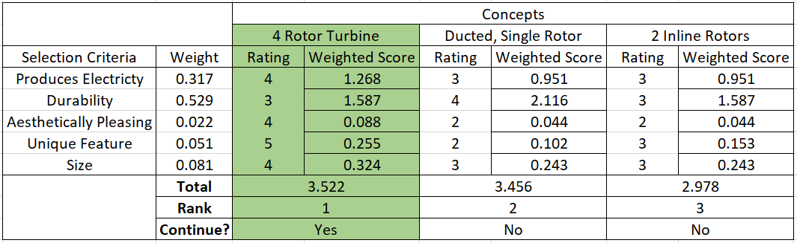

In the wind turbine project, the overall efficiency of our final design was calculated using equation 1:

$Overall efficiency=wind blade efficiency×generator efficiency×transmission efficiency$ (1)

where the wind blade efficiency is calculated using a chart that compares tip-speed ratio to the rotor power coefficient for different blade designs. In addition, the generator efficiency is calculated using a different chart that compares the RPM to efficiency percent for different PM generators, and the transmission efficiency is calculated by looking at charts online for different types of transmission systems. Since we are using a 3-blade design on all of our mini wind turbines, our wind blade efficiency is 48 percent from the chart. The generator was provided to us by the instructor and it is a 238473 PM generator and from the data for this specific generator it is roughly 35 percent efficient. We choose to use a belt pulley system for our transmission type, so when you look up this type in the chart it estimates between 95 to 98 percent efficiency. In our calculation we used 96 percent efficiency because our transmission design is somewhere in the middle of the range, but closer to the lower end. Lastly, we multiple these efficiencies together and we get an overall efficiency of 16 percent for our final wind turbine design.

CAD Drawing of Selected Design Concept

In this section, we will discuss the design concept that our team made in Solidworks. As shown in Figures 4 and 5, the proposed design is a four rotor wind turbine on a rigid post. The four rotors will be connected together with a drive belt and will spin dependently with each other. There will then be a secondary drive belt transfering the power from the turbine blades to the generator. A visual of the belt system can be seen in Figure 6. Our team's goal, in this design, is to collect the maximum amount of wind generated from the box fan. Since there were four locations on the box fan with the highest wind speeds, our concept allowed a rotor to be placed in each of these locations.
The entire turbine is assembled with a combination of ¼ - 20 threaded rod and nuts. This construction technique is shown in Figure 7 and allows for easy assembly while also allowing disassembly for later maintenance. Part drawings are located in Appendix B for each component that our team would have had to manufacture. The turbine blades and housing cover are to be 3d printed while most of the other components are to be manufactured out of aluminum stock. You can find a close up of our design for the turbine blades in Figure 8. All shafts will be machined out of steel to increase rigidity. A total of 18 R4 ball bearings will be used to allow for smooth rotation of all spinning components. Two custom sized belts will be needed to run the turbine with both being made of rubber and with the dimensions of: ⅛” x ¾” x 63.6” and ⅛” x ¾” x 17.13”. To allow for belt tensioning, a slot will be milled in the main frame members. This slot can be seen in Appendix B in Figure B-10. To allow for a gear reduction in the system, a 3” pulley is used on the rotors and a ¾” pulley is used on the transfer shafts. Using pulleys of these sizes gives us a 1:4 gear reduction and allows us to reach a more optimum turbine operating rpm.

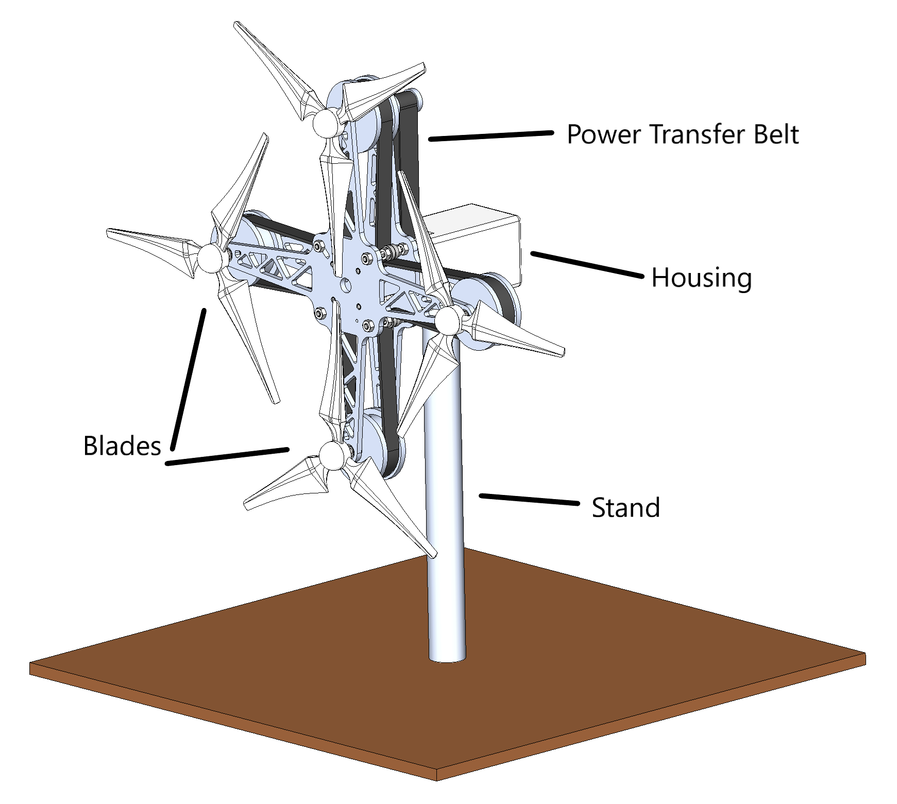
Figure 4. An overview of the proposed wind turbine design.

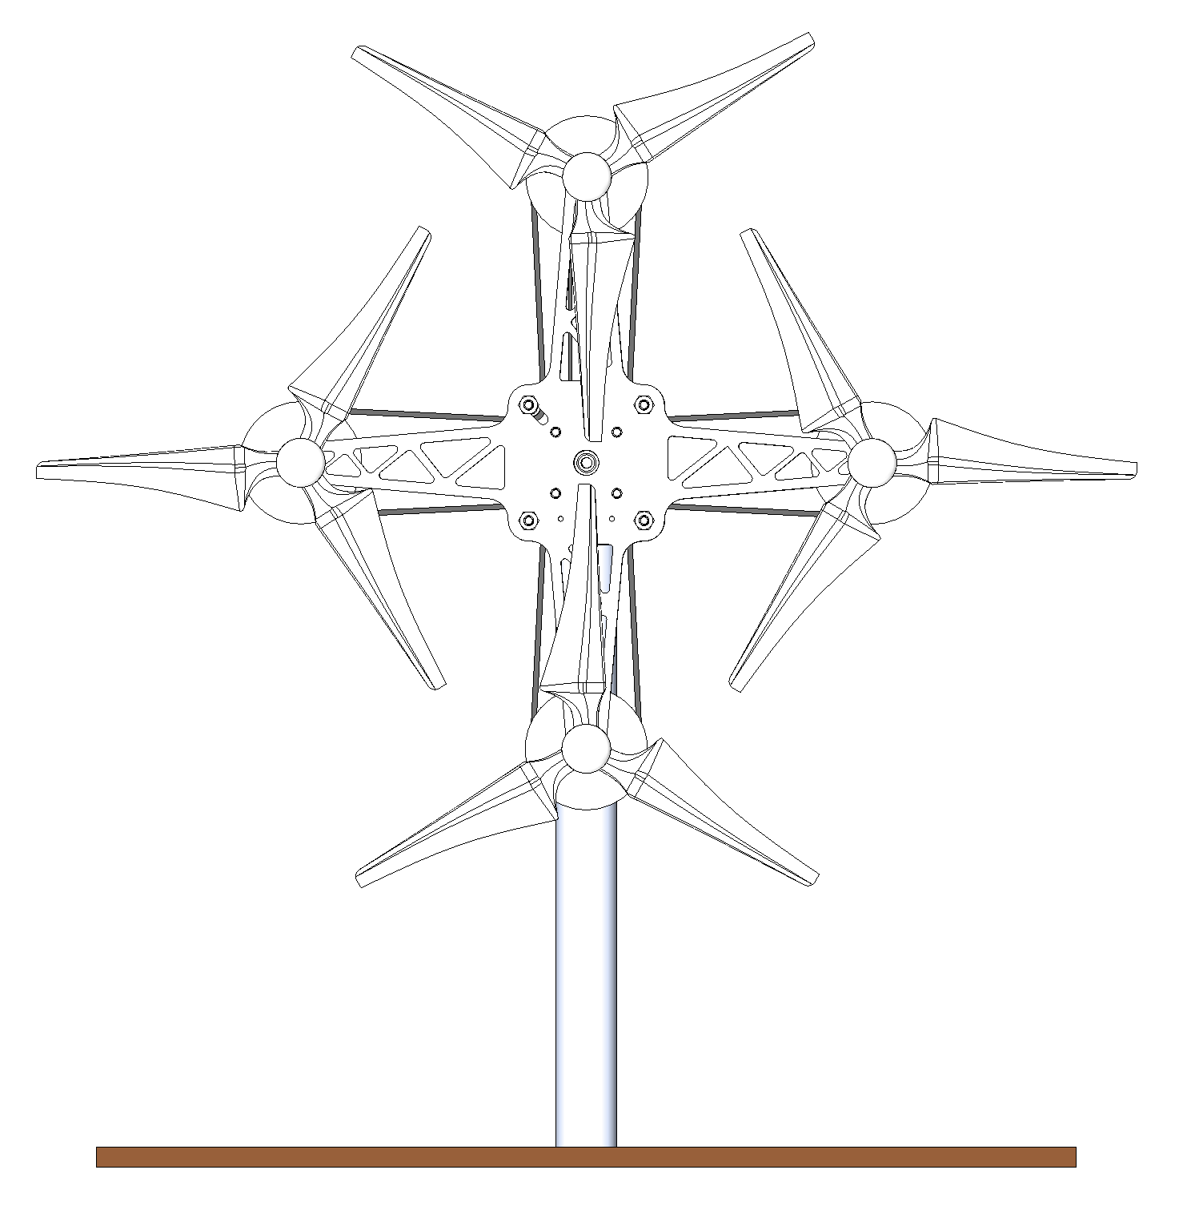
Figure 5. A front view of the proposed wind turbine design.

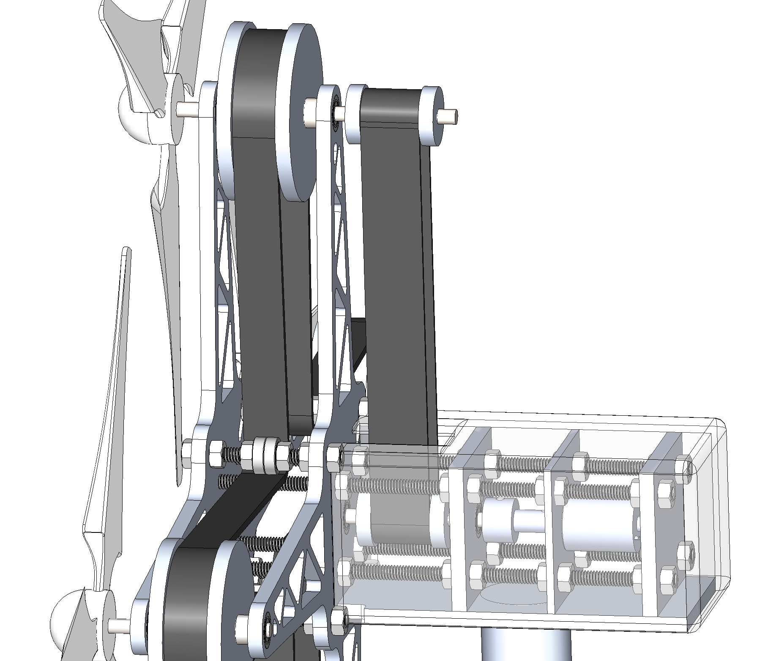
Figure 6. An overview of the belt system in the proposed wind turbine design. The rear cover has been made transparent for increased visibility of the working components.

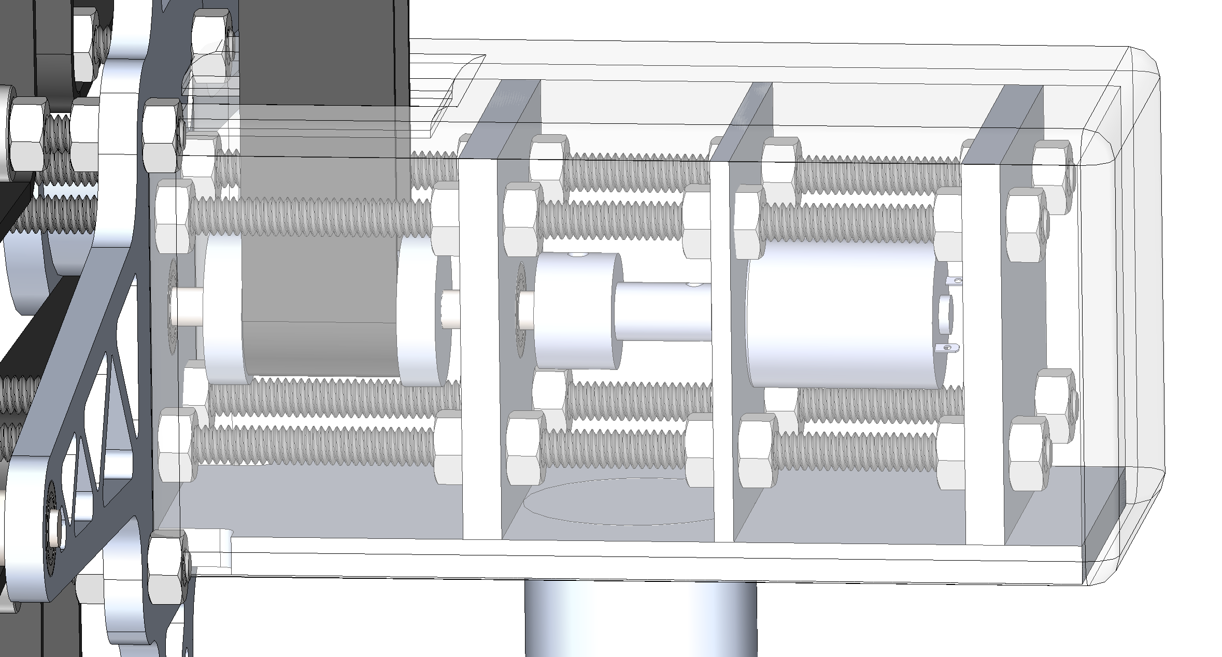
Figure 7. A close up of the transfer between the belt system and the generator. The rear cover has been made transparent for increased visibility of the working components.

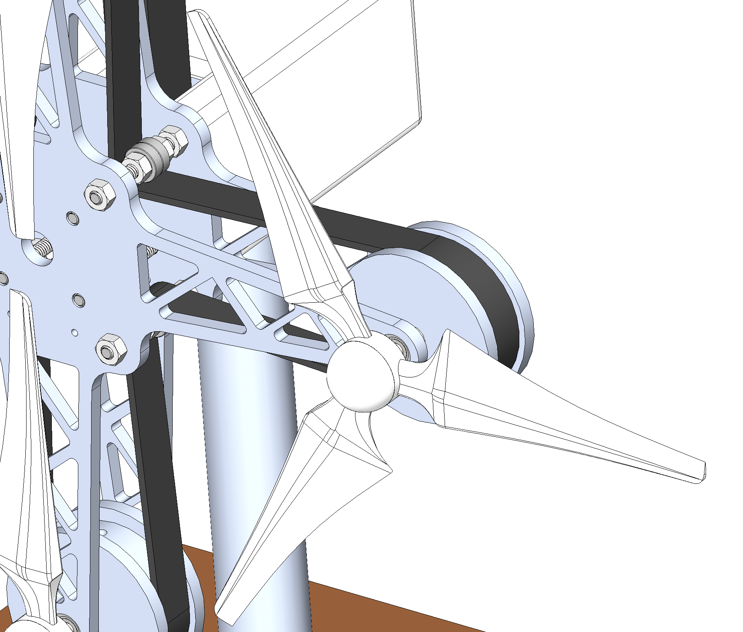
Figure 8. A closer look at one of the turbine rotors.

Management Plan

The planning of a design project of this scale requires you to create a management plan that lays out the schedule of all the tasks that need to be completed and who is going to complete them. This allows your team to be more successful and ensures tasks get completed on time. For this project, we made a Gantt chart in Excel. This can be seen in Figure 9 that outlines our timeline of tasks to be completed for the remaining of the semester. These tasks include the proposal report and the proposal presentation.
Our wind turbine design did not cost anything. The only resource we used to make our design was SolidWorks and this software is free to all Penn State students. However, if we were to actually build our wind turbine, like we planned to do before going virtual for the remaining of the semester, our turbine would have had a cost associated with it.
Our team as a whole is qualified for this project because we did thorough research on wind turbines and their applications along with background research on the region we choose to implement our design. We also have the skills needed to complete this project because we all have the prerequisite classes to this course along with different strengths and weaknesses. These strengths and weaknesses can be found in a more detailed discussion in appendix C.

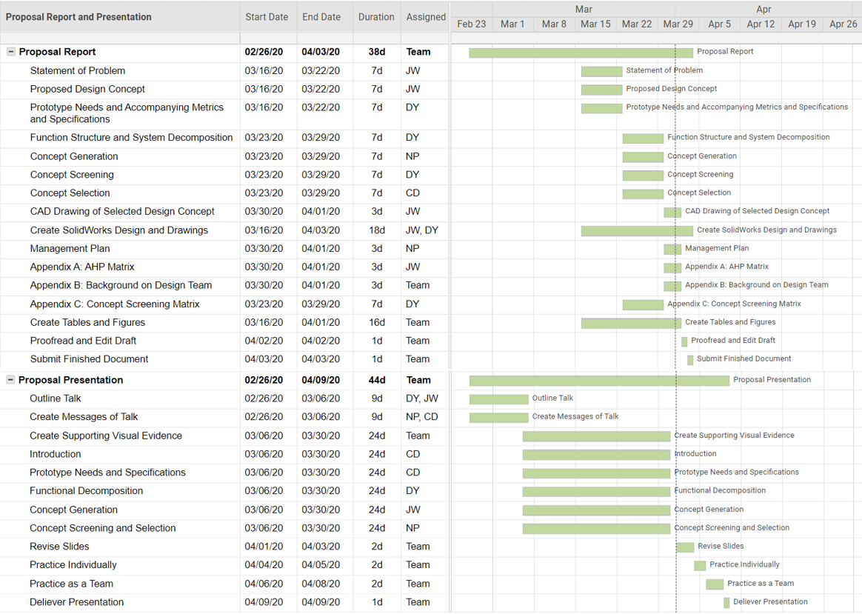

Figure 9. Gantt chart showing the remaining assignments for the rest of the semester. The Gantt chart includes the project tasks for both the proposal report and presentation, the team member(s) in charge of each task, and the dates and duration of each task.

Appendix A: AHP Matrix

In this appendix, our team presents our Analytical Hierarchy Process (AHP) that determines how much weight each customer needs has on the project. You do this by comparing the relative importance of each need to all of the other needs, which gives you the weight percent of importance out of 100 percent. As shown in Table A-1, the customer needs with the most weight was that the turbine be durable. Durability is the most important need for a wind turbine because if a turbine is broken, it can not produce electricity. The second highest weight was for the wind turbine to produce electricity. This need was expected to have a high weight because electricity production is the main purpose of a wind turbine. Our next two highest weights for the wind turbine was to have a unique feature and the size of the turbine. These needs were identified as having low weights because they both have significantly less importance on the amount of power created by the turbine. Since aesthetics have no bearing on the amount of power generated, it was identified as being the customer need with the lowest rating.

Table A-1. Analytical Hierarchy Process (AHP) matrix for our customer needs.
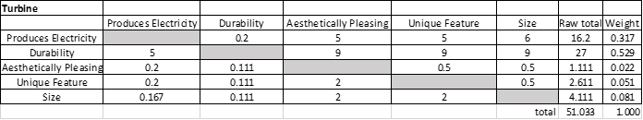

Appendix B: Detailed Part Drawings

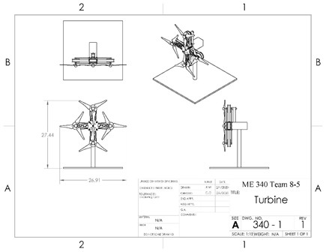
Figure B-1. Technical drawing of the entire small-scale wind turbine.

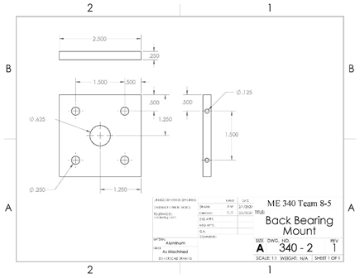
Figure B-2. Technical drawing of the back bearing mount on the small-scale wind turbine.

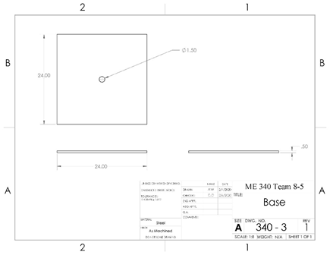
Figure B-3. Technical drawing of the base on the small-scale wind turbine.

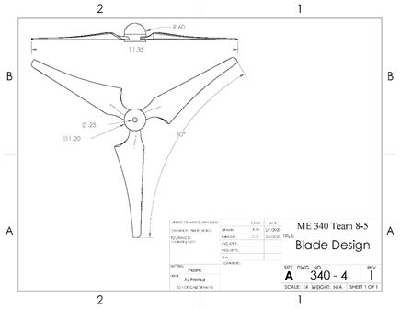
Figure B-4. Technical drawing of the blade design on the small-scale wind turbine.

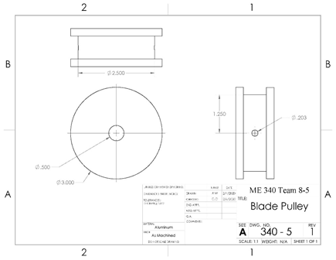
Figure B-5. Technical drawing of the blade pulley on the small-scale wind turbine.

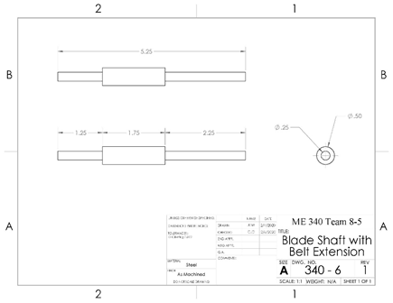
Figure B-6. Technical drawing of the blade shaft with belt extension on the small-scale wind turbine.

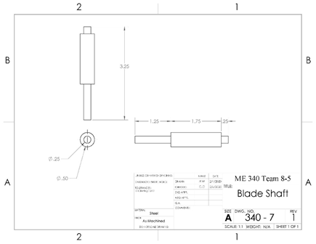
Figure B-7. Technical drawing of the blade shaft on the small-scale wind turbine.

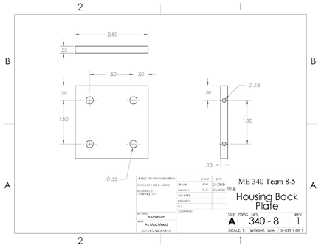
Figure B-8. Technical drawing of the housing back plate on the small-scale wind turbine.

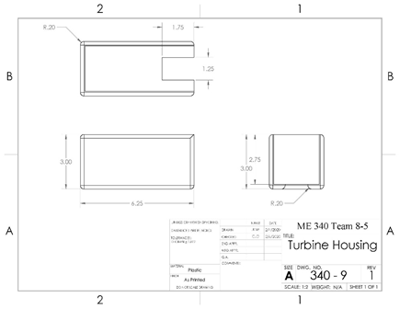
Figure B-9. Technical drawing of the turbine housing on the small-scale wind turbine.

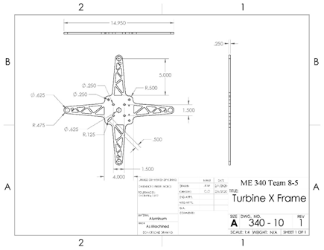
Figure B-10. Technical drawing of the turbine X frame on the small-scale wind turbine.

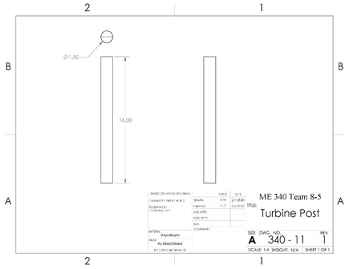
Figure B-11. Technical drawing of the turbine post on the small-scale wind turbine.

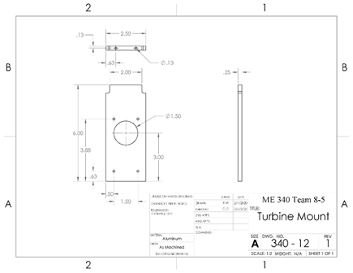
Figure B-12. Technical drawing of the turbine mount on the small-scale wind turbine.

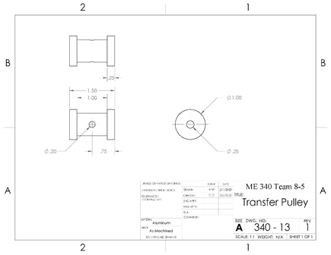
Figure B-13. Technical drawing of the transfer pulley on the small-scale wind turbine.

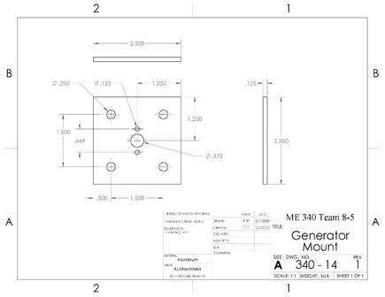
Figure B-14. Technical drawing of the generator mount on the small-scale wind turbine.

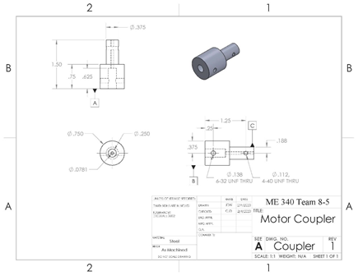
Figure B-15. Technical drawing of the coupler on the small-scale wind turbine.

Appendix C: Qualifications of Design Team

This appendix presents background information about each member of the design team that is creating this wind turbine. A picture of each member is shown in Figure C-1 and below that are the biographies of each member that will follow the same order.





Figure C-1. Photo of each member of the team. Named from left to right: Nicole Polakovic, Daniel Yednock, Jeffrey Will and Cyrus Darvish.

Nicole Polakovic is a junior in mechanical engineering at The Pennsylvania State University. Originally from Pittsburgh, Pennsylvania, she had an internship last spring with the Walt Disney World Resort Company in Monorail Operations. During this internship, she learned the importance of safety and efficiency by performing vehicle checks during opening procedures and providing quick and reliable transportation to several thousand guests a day. In addition, she strengthened her communication skills through two-way radio communication and her problem solving skills by quick thinking when encountering an unusual condition. Just this year, she started working for the Penn State Hockey team as the Student Equipment Manager and she currently still works in this position. In this job, she has to pay attention to details to step up the locker room and benches and is in charge of repairing all faulty equipment. Outside of school and work experience, Nicole can be seen as a leader as she is currently in charge of a design team with the Penn State Theme Park Engineering Group. In this design group, they are fabricating a ride vehicle for their 3D printed track they created for their themed roller coaster design. In addition, she was involved with another project in this club that designed a themed haunted house that was in accordance with all the building safety codes. Lastly, Nicole is very passionate about curling and travels with the Penn State Curling Club to compete against other schools.
Daniel Yednock is a junior at Penn State and is studying mechanical engineering. A member of the Alpha Fire Company in State College, he has successfully completed his Firefighter 1 certification and is currently training to be an apparatus driver-operator. He is also the vice president of the National Wild Turkey Federation Spur Collectors- Penn State Chapter. This organization is dedicated to conservation and introducing college students to the outdoors. When not at school, Daniel manages his own landscaping business over the summer months. To gain valuable experience in the engineering field, he interned with SNC-Lavalin last summer and worked as a project engineer overseeing industrial and manufacturing job sites. After this semester, Daniel will be working at JLG Industries in Hagerstown, Maryland as a systems engineer intern.
Jeffrey Will is a senior mechanical engineering student attending Penn State. While a student, he has had the opportunity to complete two summer internships with Premier Automation and Bayer Pharmaceuticals. After completing this semester, Jeffrey will be furthering his internship career at Radio Flyer working as a prototype engineer. Although these experiences have been valuable, his passions lie in working with his hands. He has a full wood and metal shop and has knowledge in many manufacturing techniques. Since he was 16, Jeffrey has been building an 11ft wooden boat and is hoping to get it in the water this summer. Some of his extracurricular activities include rock climbing, running, camping and water and snow skiing.
Cyrus Darvish is a junior mechanical engineering student at Penn State University. During his time as a college student, he has had one summer internship at the Temple University College of Engineering. At the university, he participated heavily in the Temple Biomechanics Lab. In the lab, he participated in three major research projects. These projects include testing of kevlar fibers in high rate loadings, thoracic behind armor blunt trauma, and linear and rotational traumatic brain injury. Through these projects he contributed with hands-on experimentation, experiment method design, and post experiment analytics. This summer, he will continue his research at the Temple Biomechanics Lab. Some of his other activities include running and intramural sports such as soccer and football.

Appendix D: Concept Screening Matrix

Table D-1: Concept screening matrix for the coupler design.
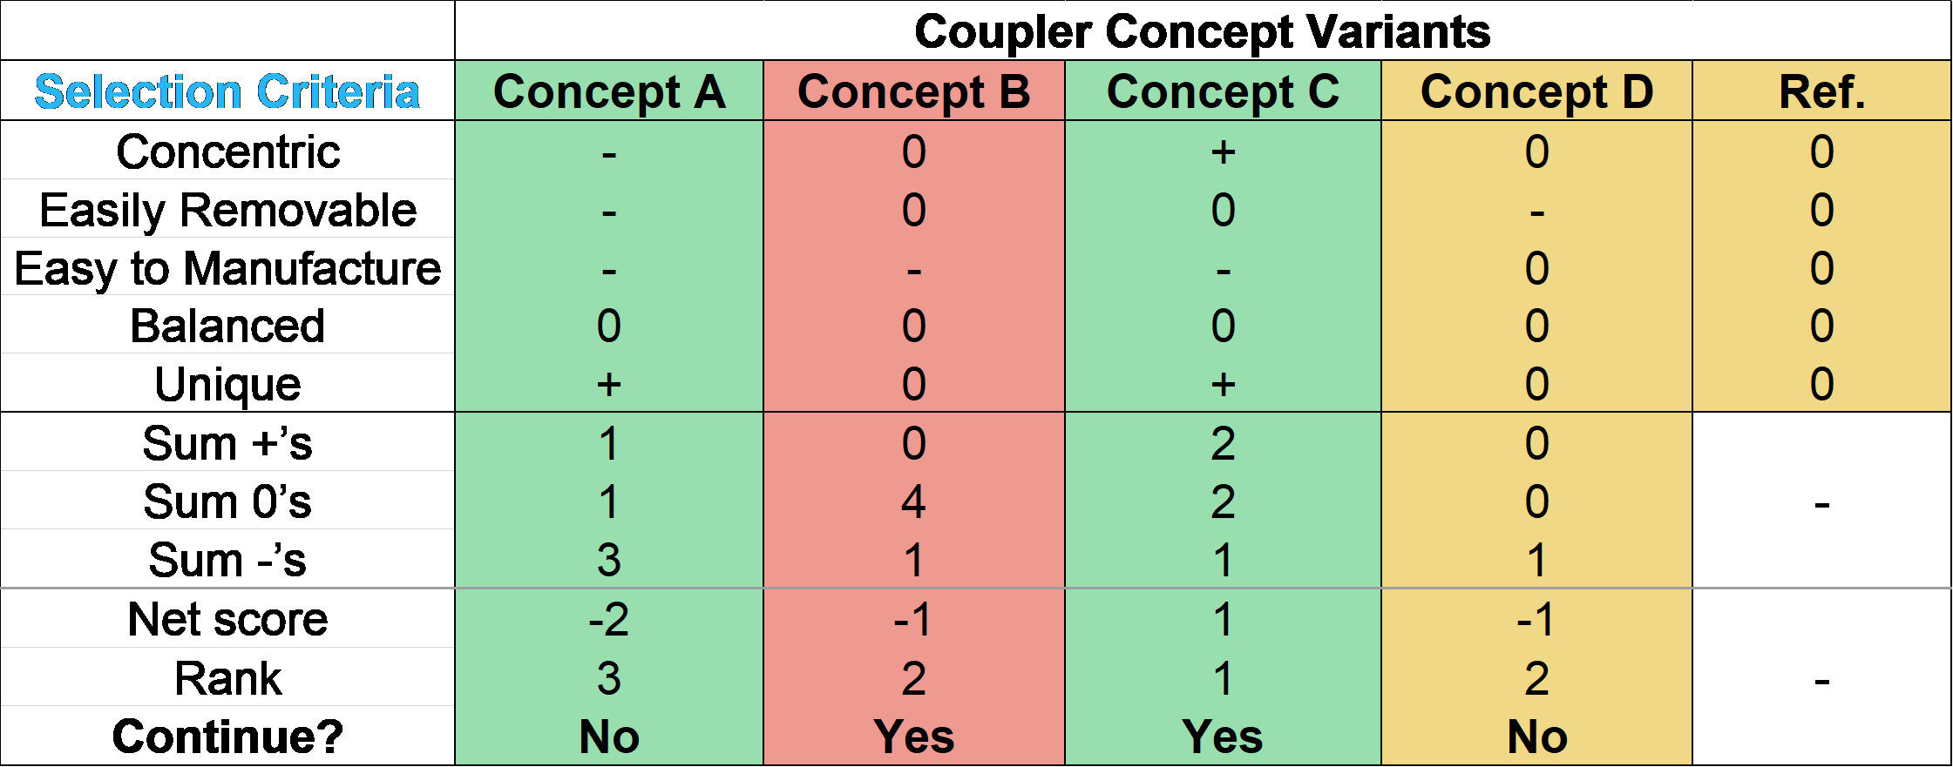
Note - Concepts in order from left to right: Threaded Coupler, stepped coupler, callet assembly, and permanent design.

Table D-2: Concept screening matrix for the protection design.
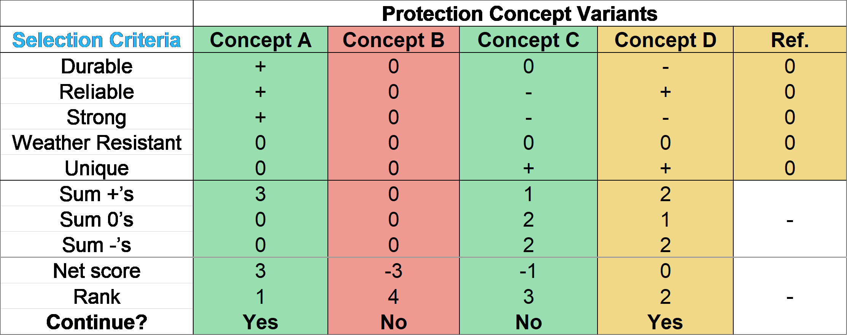
Note - Concepts in order from left to right: Designed for high speed, built in a safe location, guard dog, and blades fold back.

Table D-3: Concept screening matrix for the support design.
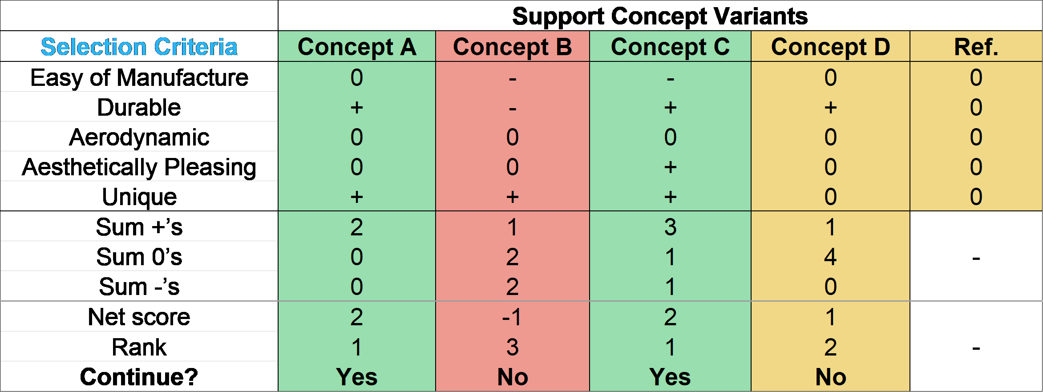
Note - Concepts in order from left to right: Stand with cables to ground, floating balloon turbine, truss-stand, and fully machined aluminum.

References

https://www.unicefusa.org/stories/how-long-does-it-take-get-water-aysha-eight-hours-day/30776
https://www.bbc.com/news/world-africa-30627861
- Banas, Michael Anthony, Crawford, Mary Hagerott, Ruby, Douglas Scott, Ross, Michael P., Nelson, Jeffrey Scott, Allerman, Andrew Alan, and Boucher, Ray. Final LDRD report :ultraviolet water purification systems for rural environments and mobile applications.. United States: N. p., 2005. Web. doi:10.2172/876370.
- “Water Crisis - Learn About The Global Water Crisis.” Water.org, 2020, water.org/our-impact/water-crisis/.
- “Tanzania's Water Crisis - Tanzania's Water In 2019.” Water.org, 2019, water.org/our-impact/tanzania.
- Unknown. “How to Make a Windmill That Generates Electricity.” How to Make a Windmill That Generates Electricity, 2 Apr. 2015, windsolarpwr.blogspot.com/2015/04/how-to-make-windmill-that-generates.html.
- “Global Climate Station Summaries Map: GIS Maps.” National Centers for Environmental Information (NCEI), 31 Dec. 2015, gis.ncdc.noaa.gov/maps/ncei/summaries/global.
- “How Does a Wind Turbine Work?” Energy.gov, www.energy.gov/maps/how-does-wind-turbine-work.
- Iberdrola Corporativa. “The Main Curiosities of Wind Turbines and Its Blades Revealed.” Iberdrola, www.iberdrola.com/press-room/top-stories/wind-turbines-blades.
- http://www.fraserengineering.com/blog/effective-low-cost-water-treatment-for-process-systems-with-ultraviolet-technology/
- Schubel, Peter J., and Richard J. Crossley. “Wind Turbine Blade Design.” MDPI, Molecular Diversity Preservation International, 6 Sept. 2012, www.mdpi.com/1996-1073/5/9/3425
- “The Inside of a Wind Turbine.” Energy.gov, www.energy.gov/eere/wind/inside-wind-turbine.
- Wind Turbine Towers. Danish Wind Industry Association, 19 Sept. 2003, xn--drmstrre-64ad.dk/wp-content/wind/miller/windpower%20web/en/tour/wtrb/tower.htm.

